Benjamin Abbott

CS 330

Comp Graphic and Visualization

June 16, 2022

**Project Review**

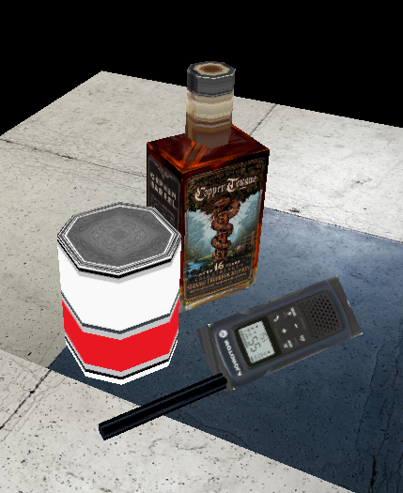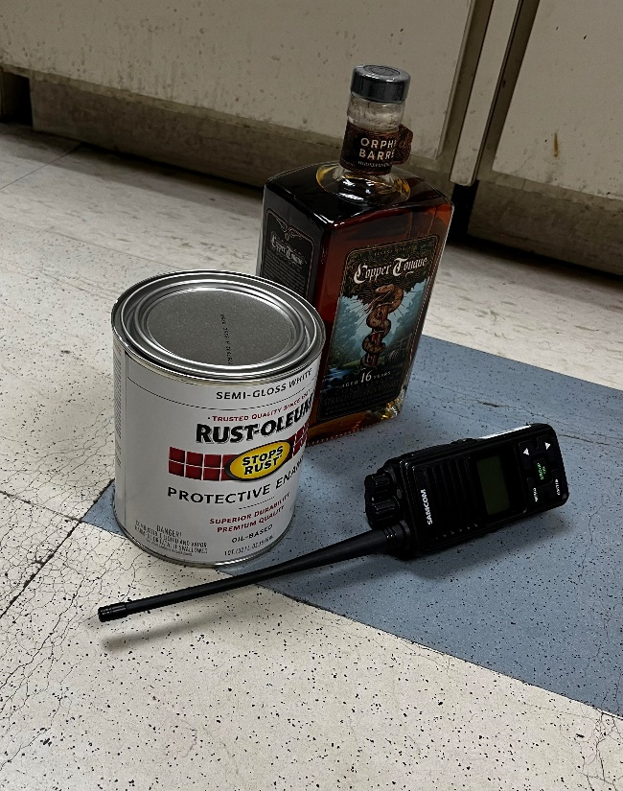

My 3D scene consisted of four objects. A bottle of whiskey, a small can of paint, a two-way radio, and the floor they were sitting on. I noticed that two of my objects, the bottle and the radio were somewhat parallel, so I decided to plot those along the x and the y axis to make moving them easily. With the sides of these objects all being different I wanted to texture each side with different images. I decided to make multiple primitives to create the objects. To make the whiskey bottle, I ended up creating 6 different primitives. This included the four sides of the bottle as quads to create a cuboid, four triangles to make up the pyramid to make the top of the bottle, and 24 triangles to make up the bottle neck in the shape of an octagon. The two-way radio consisted of three different primitives. The face, the body, and the antenna since these were the three different textures that were on the object. I used quads to create all these objects. The paint can was created with two primitives, the top and bottom of the can were one and the sides were the other. I used quads for the sides of the can and triangles for the top and bottom. The last object was the floor which I created using quads. After using the translation function to place the bottle, the radio and the paint can as close to the photo as I could, I was able to move around and rotate the floor plane to get the tiled floor to match up as close to the picture as possible.

The user is able to navigate through the scene by moving the camera with the keys, W for up, S for down, A for left, and D for right. The Q and E keys also let the user move up and down along the z-axis. The user is also able to move the view of the camera around with the mouse. When I first implemented the orbit function, it was a little hectic, so I decided to make the user have to press and hold the left mouse button to enable orbit. I found this to be a preferable way to navigate and similar to the movements in the Blender application that I use frequently. The user is also able to change their view from perspective to orthographic and back with the keys P for perspective and O for orthographic if they choose.

The custom functions that my program used to make the code more modular were the shaders. This allowed the shader to be used by each object when called upon instead of making a new shader for each object. I also used a rotate, translate, and scale functions to move around the primitives. This allowed me to reuse and call them when needed with different inputs.